**Education organisation using servicenow**

**Team Id: NM2025TMID16364**

**Team Members: 4**

**Team Leader: Bharathi S**

**Team Member 1 Bharathi S**

**Team Member 2 Kamini V**

**Team Member 3 Kanchana R**

**Problem Statement:**  The Educational Management System is a comprehensive platform designed to streamline administrative tasks within educational institutions. It facilitates efficient management of student and teacher data, simplifies the admission process, and provides tools for monitoring student progress.

**TASK INITIATION**

**Milestone 1 : Creating Update set**

**Activity 1: Create local update set**

1. Open service now
2. Click on All >> search for Local Update set
3. Select Users under system Definition
4. Click on new
5. Fill the following details to create a new Local Update set
6. Click on submit and make Current

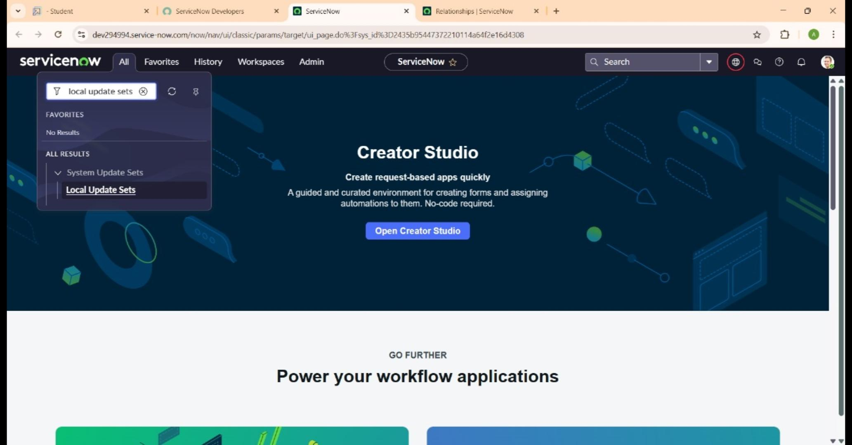

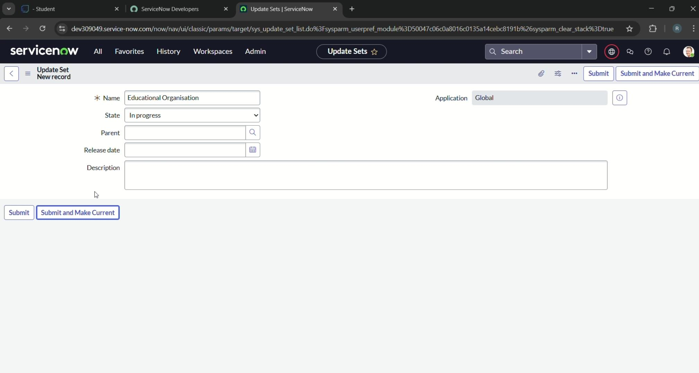

**Activity 1: Creating Salesforce table**

1. Open service now.
2. Click on All >> search for Table
3. Select Table under system Definition
4. Click on new
5. Enter the Label Salesforce>>Click on name it will be automatically generate API
6. Create column as given below, double click on column label and enter the colum labels on click on the tick mark>>Given type as given
7. Right Click on the toggle bar and save
8. Click on control >>enable extensible

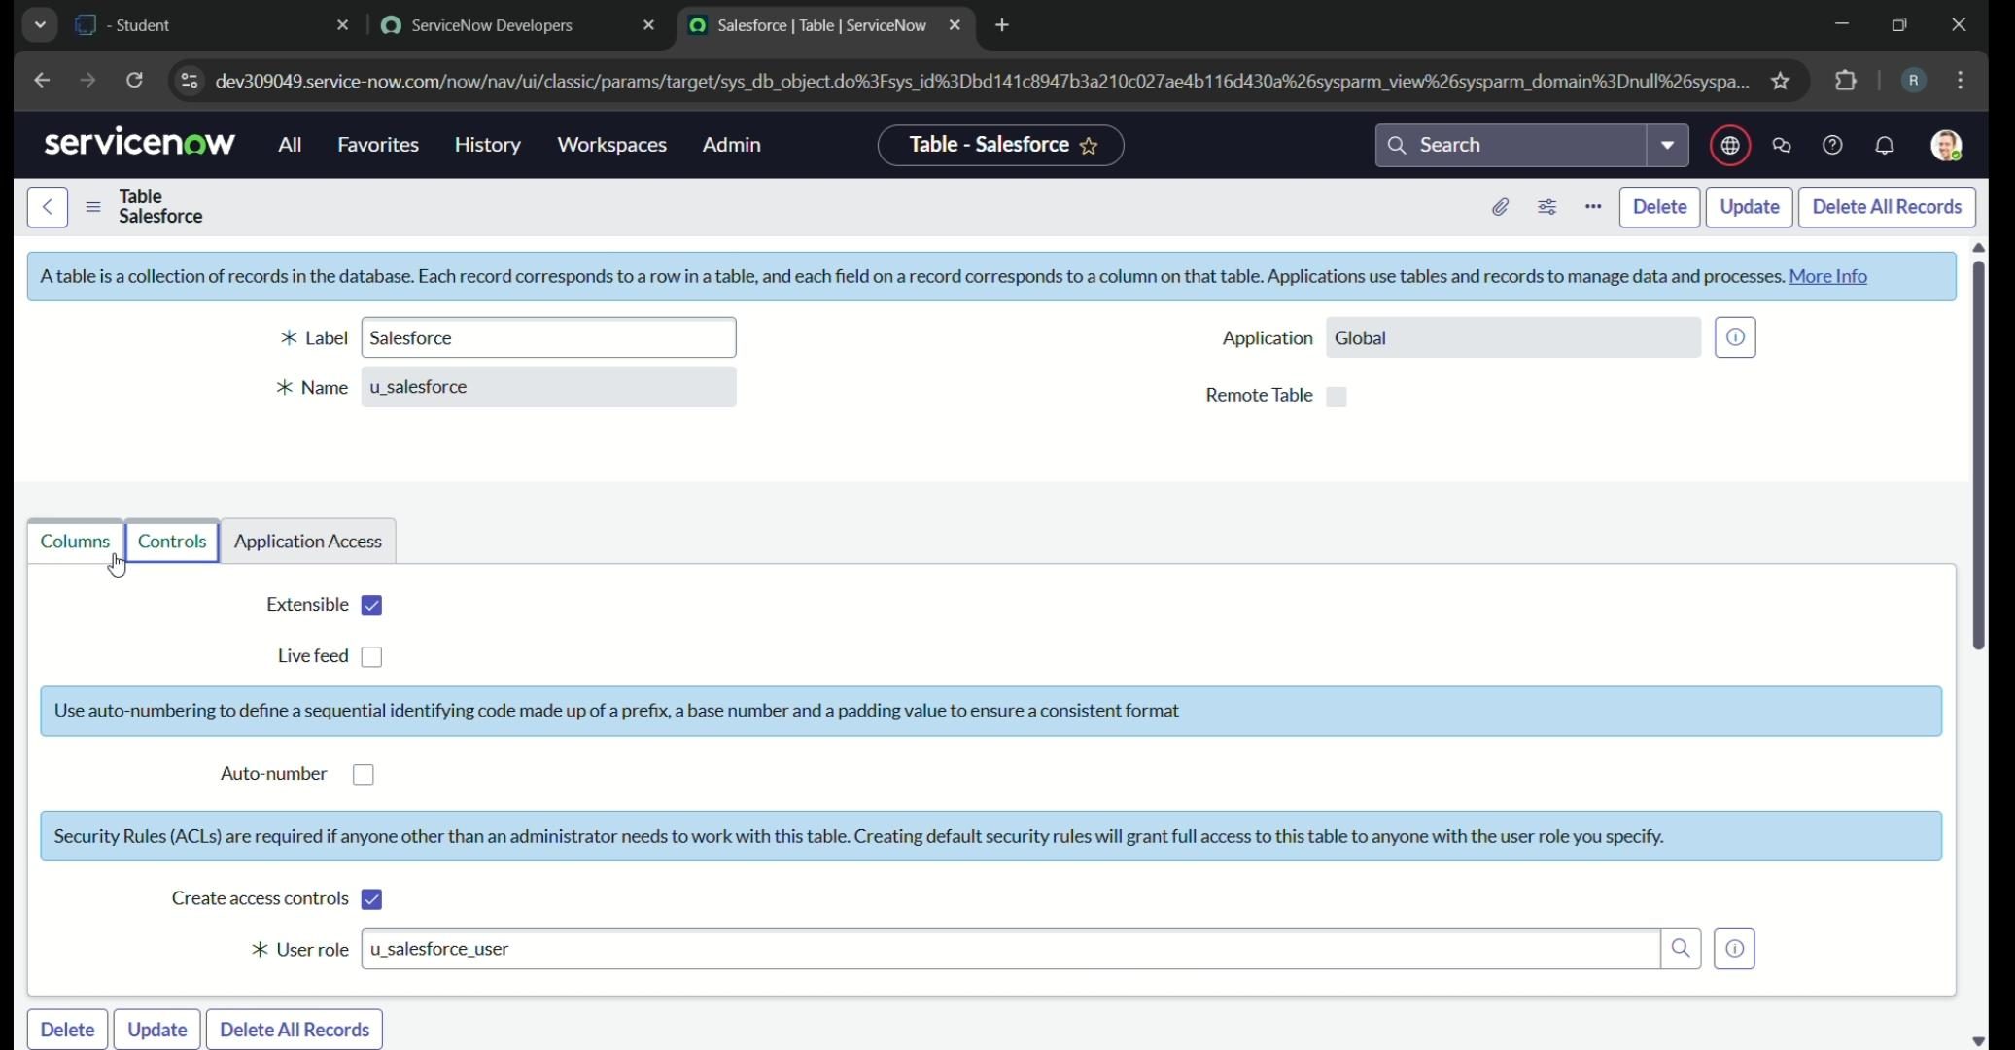

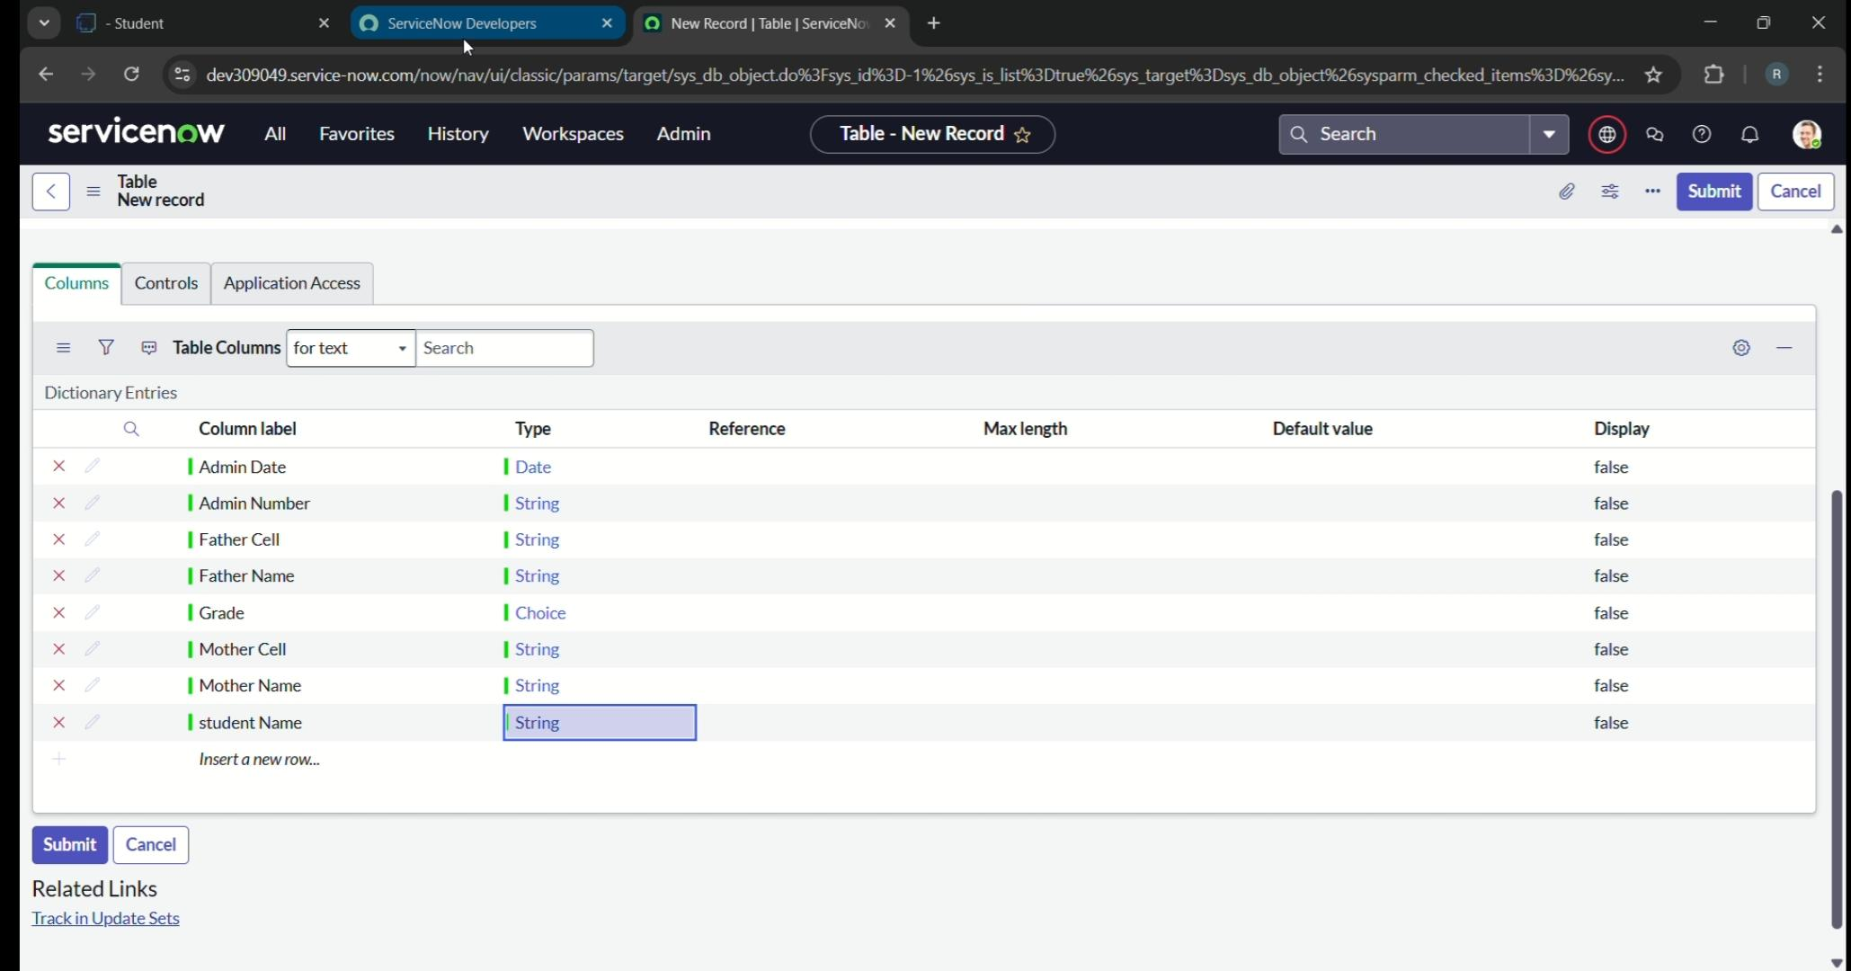

1. Click on Admin number colum, in related link click on the advance to view>> Default view(enable use dynamic default)>> Select get next padded number in dynamic default value>>>Update

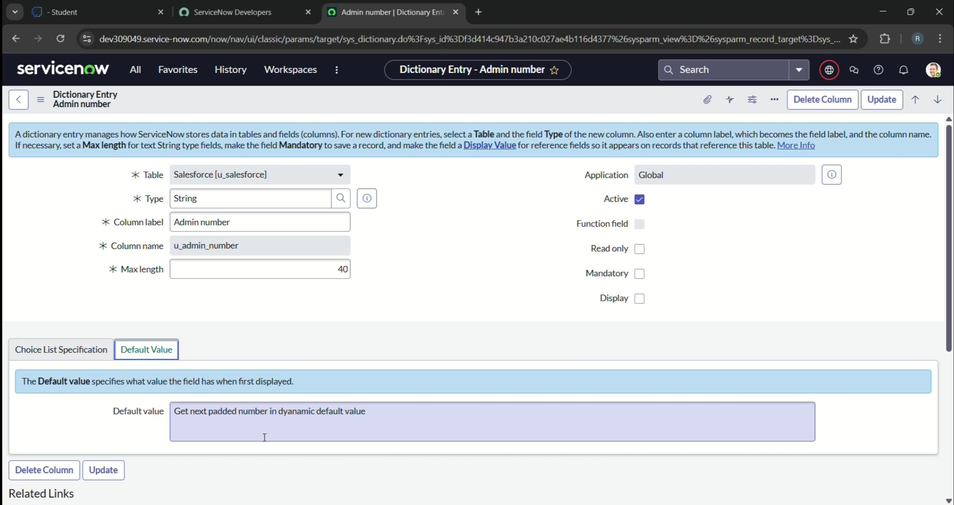

1. Click on Grade column>> click on choice and give label value and sequence as given below

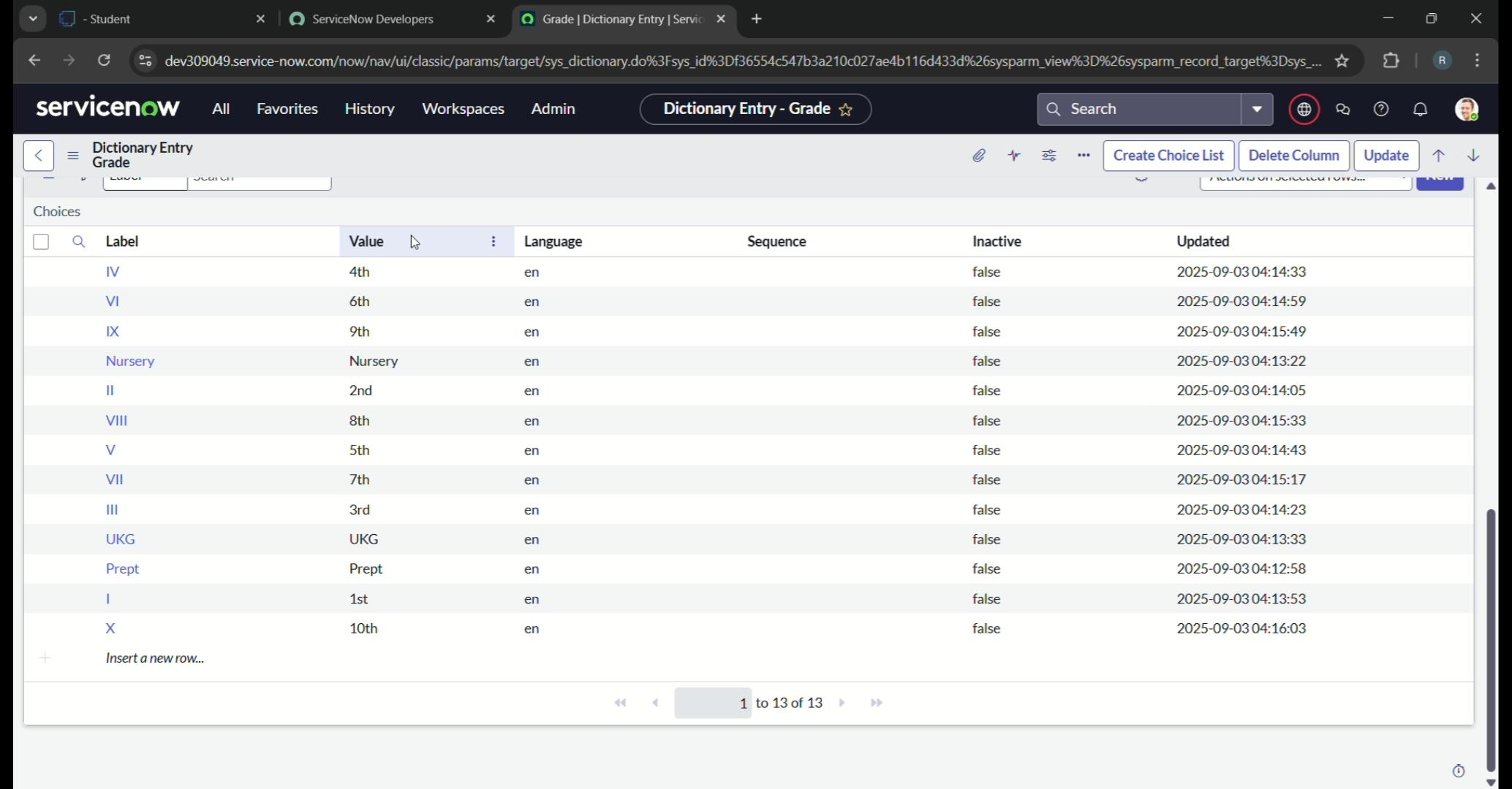

**Activity 2 : Creating Admission table**

1. Create an admission table with column given
2. Select extends table>> salesforce and also select at model to Menu>> salesforce
3. Create fields as shown

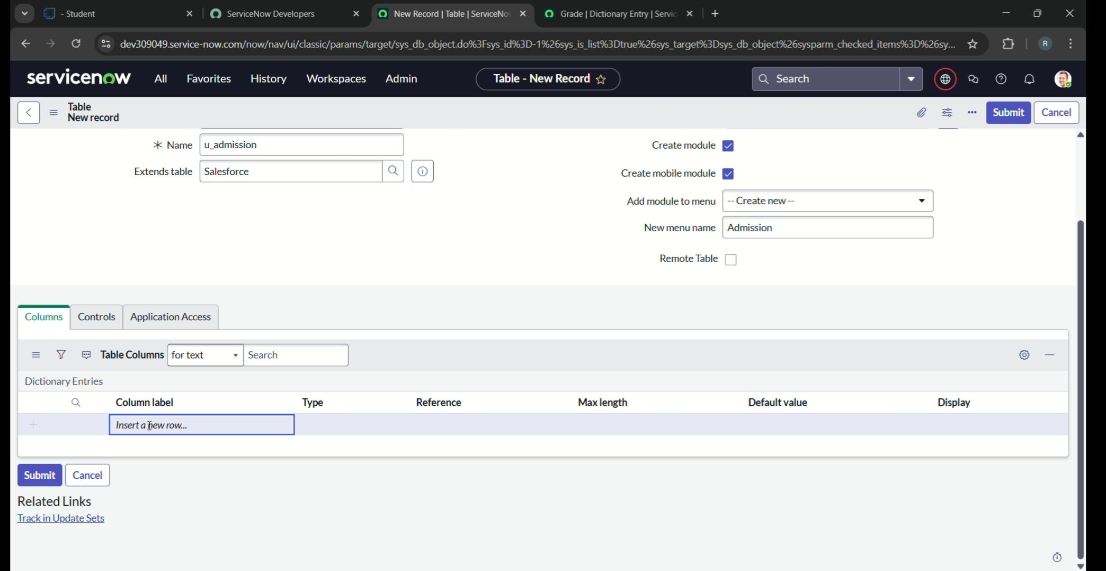

1. Create choice for admin status as:

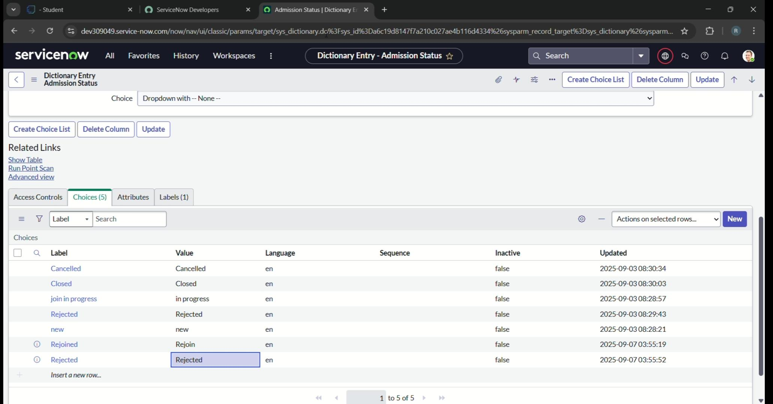

1. Create choice for Pincode as

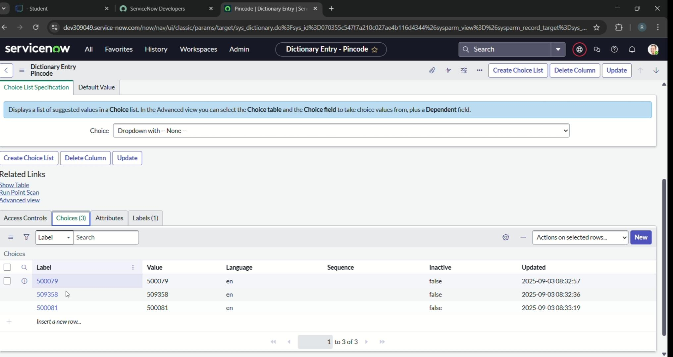

1. Create choice for Purpose of join as: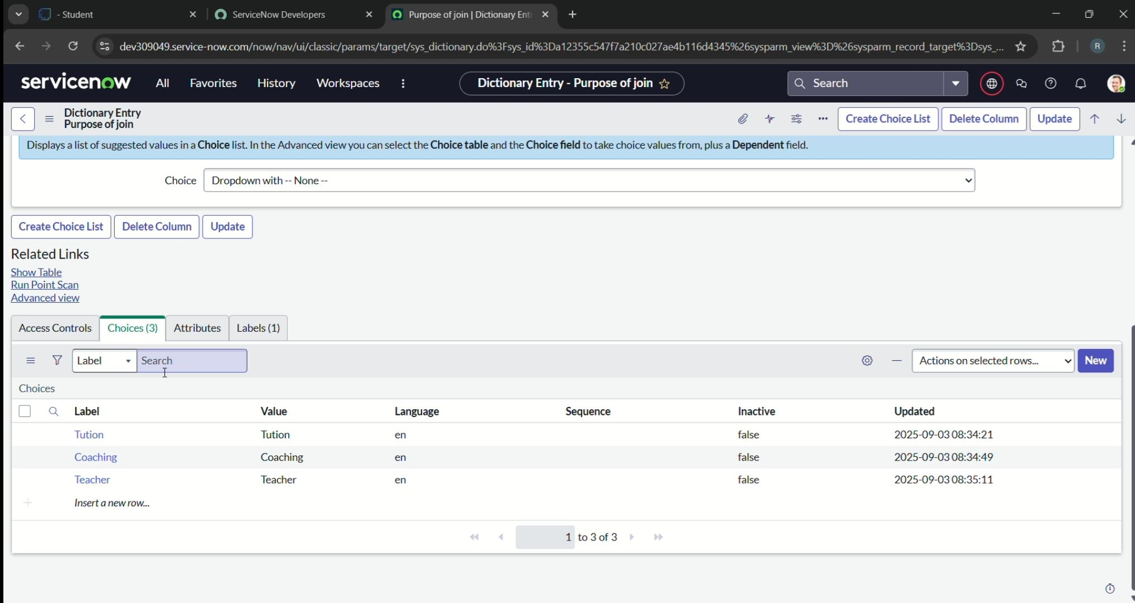
2. Create choice for school as:

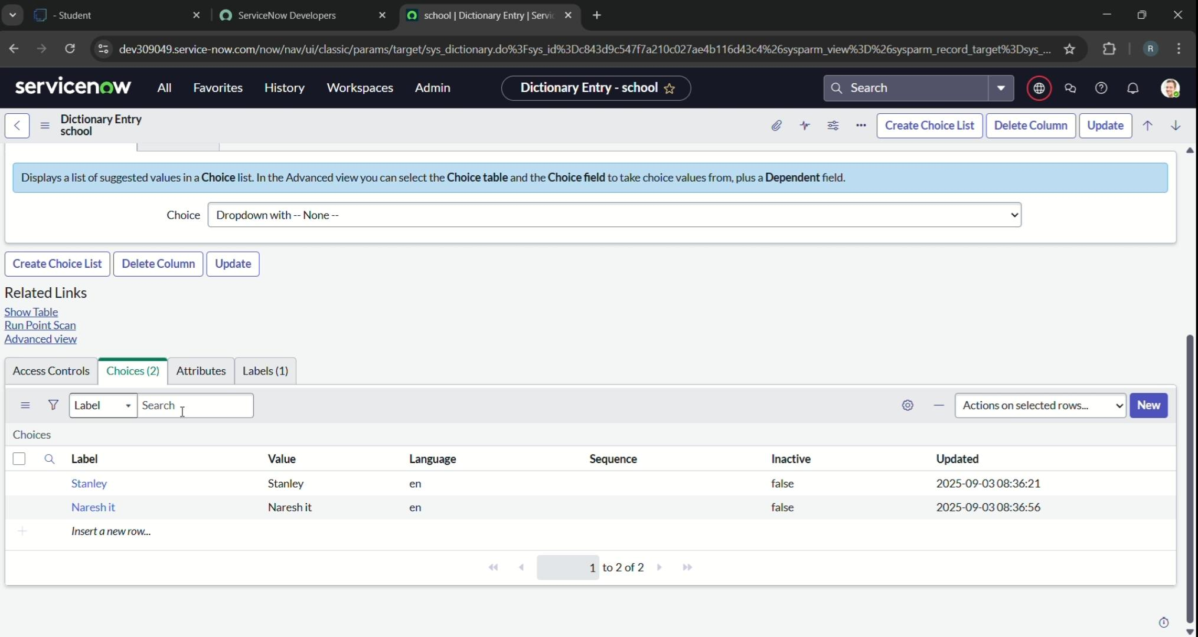

1. Create choice for school area as;

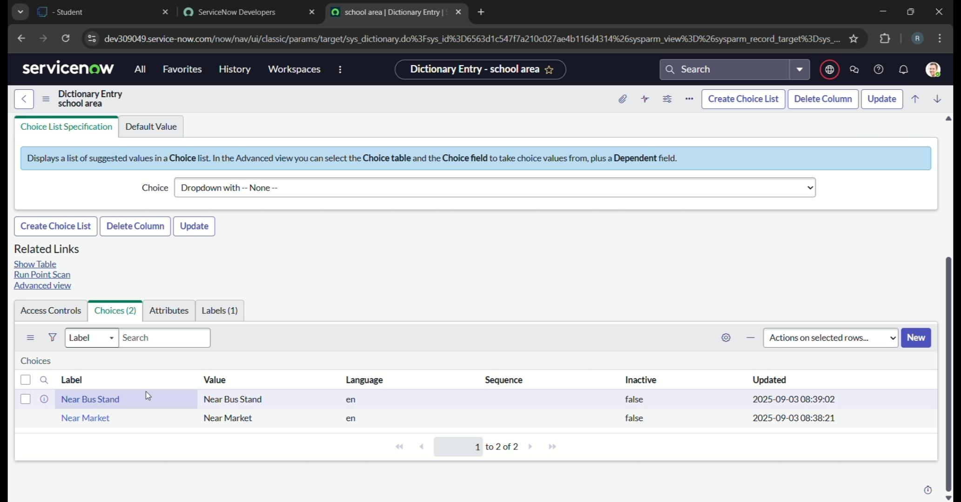

**Activity 3: Create Table Student progress**

1. Created a Student Progress Table with Column given.
2. Select Add Module to Menu>> Salesforce
3. 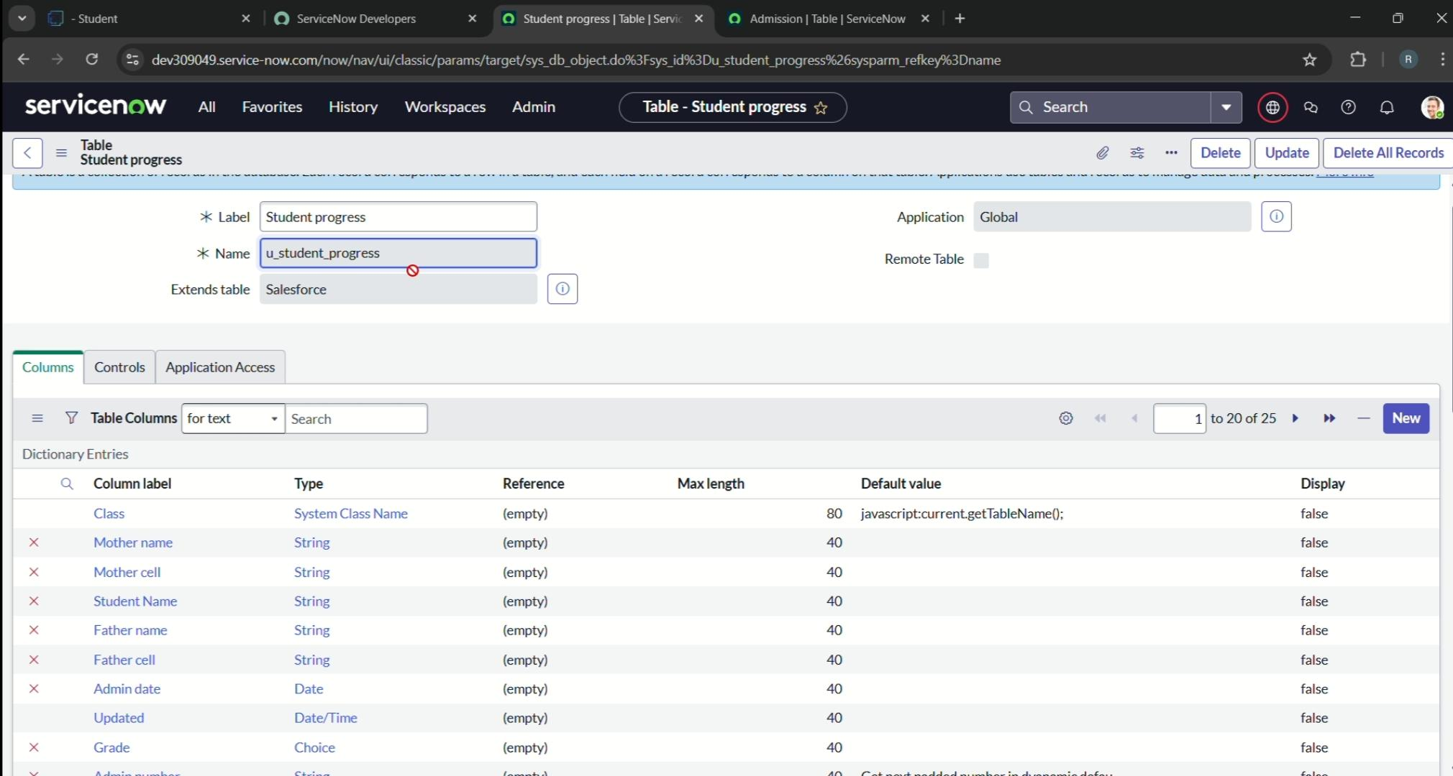Create Fields as shown.

**Milestone 3: Form layout**

**Activity 1: configuring table from for student progress table**

1. In this student progress table page click on layout from
2. Click on admission number
3. Select below admission number field In available side And send it selected Side as below>> save

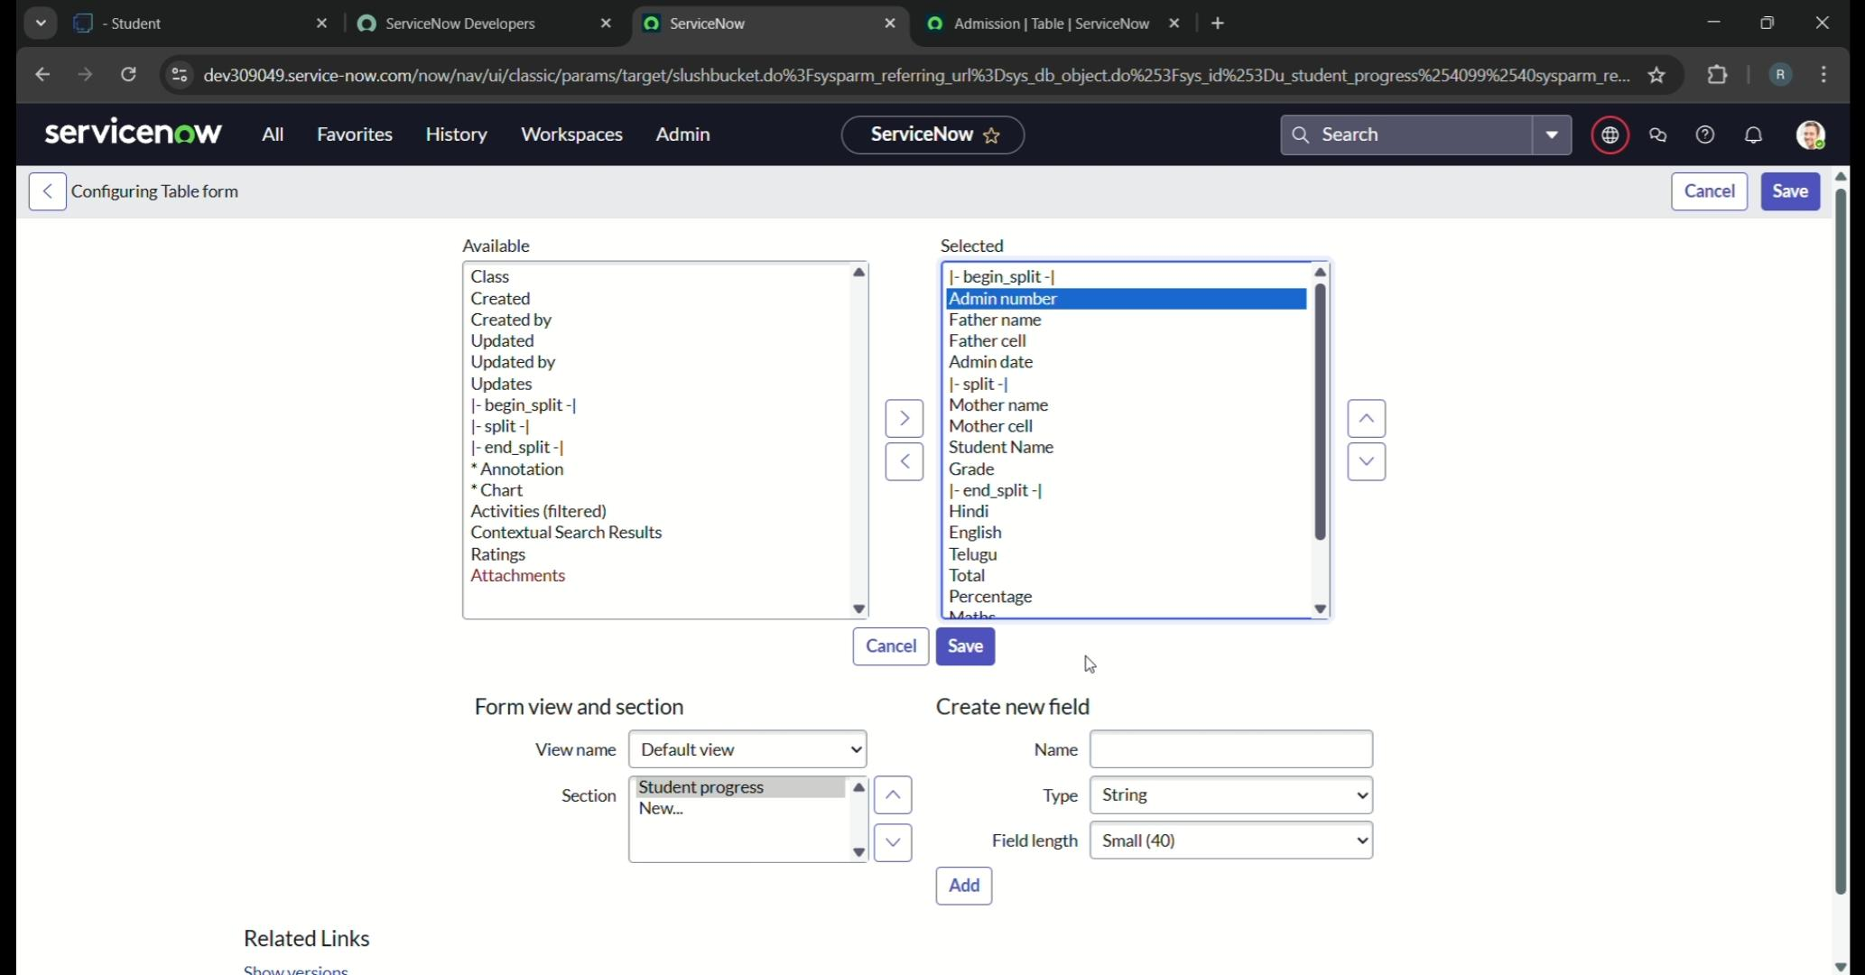

**Milestone 4: Form Design**

**Activity 1: Creating form Design for Salesforce table**

Open service now.

1. Click on All >> search Table
2. Select tables under system definition
3. In label search for Salesforce And Open
4. Right click On top Toggle >>Configure>> From design
5. In Drop Select Salesforce (u_Salesforce)
6. Drag and drop the field to the left side as below
7. Save

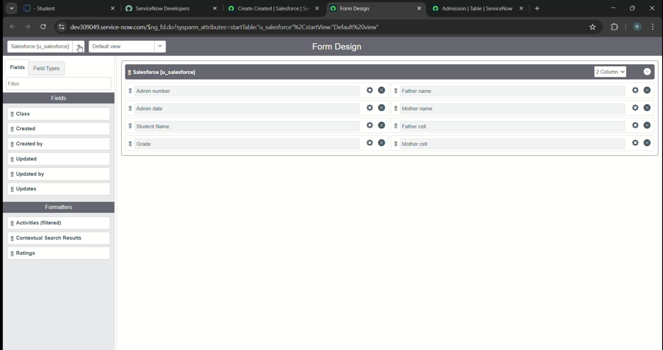

**Activity 2: Creating form Design for Student progress table**

1. .Open service now.
2. Click on All >> search Table
3. Select tables under system definition
4. In label search for student progress And Open
5. Right click On top Toggle >>Configure>> From design
6. In Drop Select student progress (u_student_progress)

Drag and drop the field to the left side as below

1. 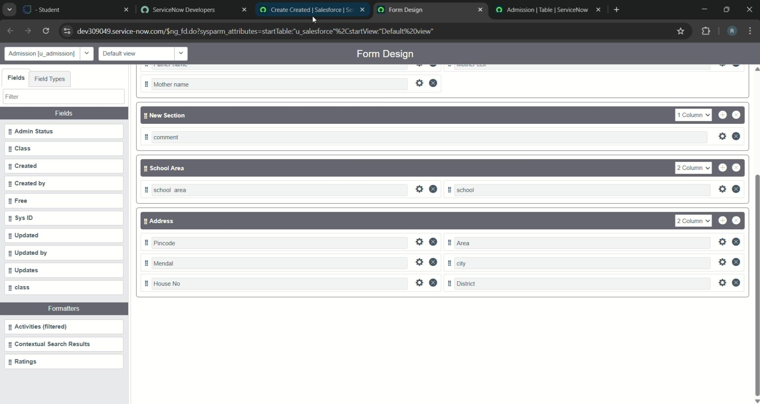Save

**Activity 3: Creating from Design for Admission table**

1. Open service now.
2. Click on All >> search Table
3. Select tables under system definition
4. In label search for Admission And Open
5. Right click On top Toggle >>Configure>> From design
6. In Drop Select Admission (u_admisdion)
7. Drag and drop the field to the left side as below
8. Save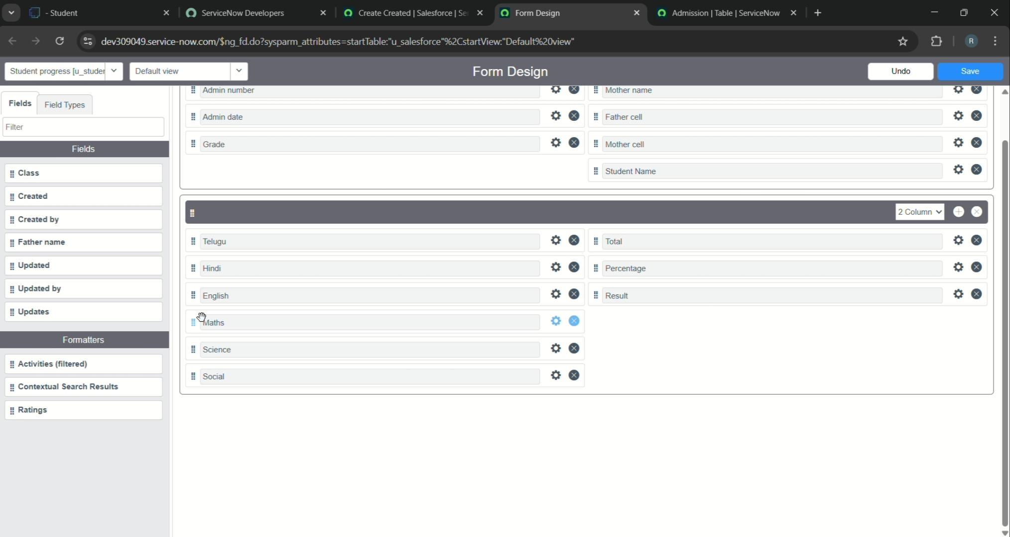

**Milestone 5 : Number Maintenance**

**Activity 1: Creating number maintenance for acne number**

1. All>>Number maintenance>>new
2. 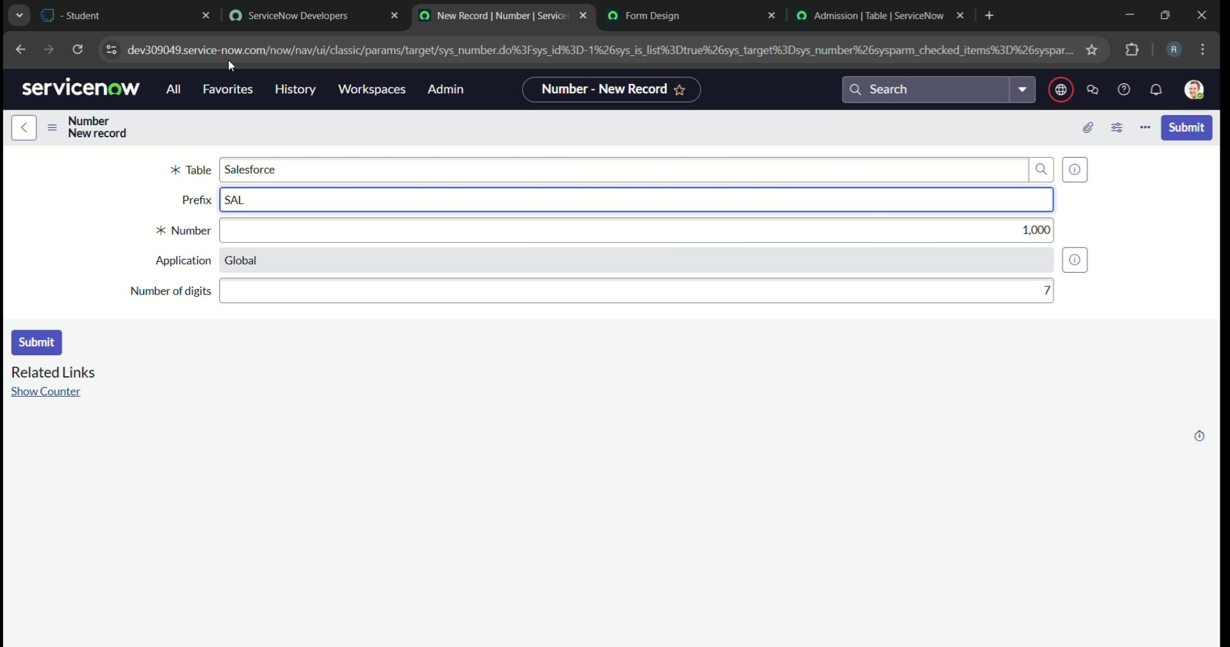Fill the details>>summit

**Milestone 6 : Process Flow**

**Activity 1: Creating process flow for admission table**

1. Open service now.
2. Click on All >>Process Flow>>New
3. Fill the details as given below
4. Right Click on Toggle and click on the save.

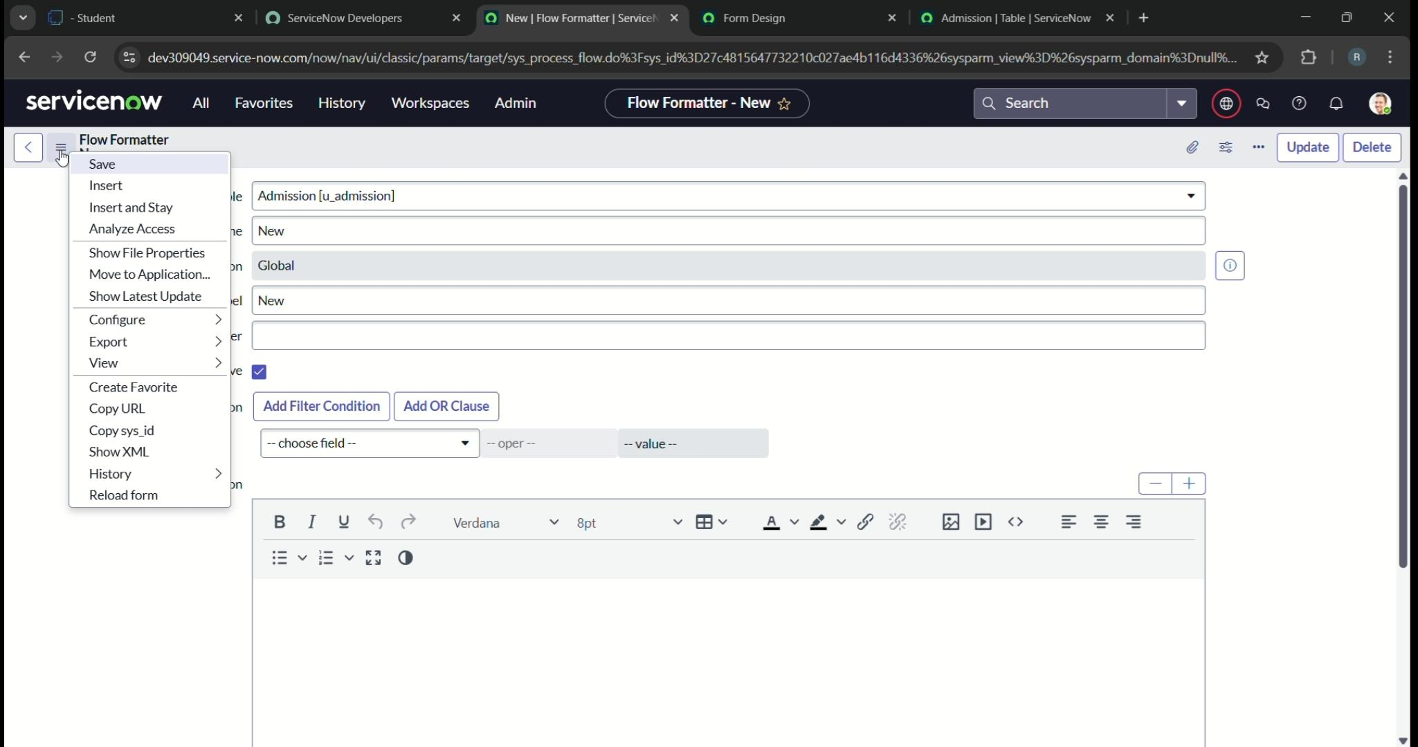

1. Replace the name and label as below and click on insert on stay
2. Replace the name and label in order and click on insert on stay joined>>Rejected>>Rejoined>>Closed>>Cancelled
3. Order should be new>>In progress>>Joined>>Rejoined>>Closed>>Cancelled

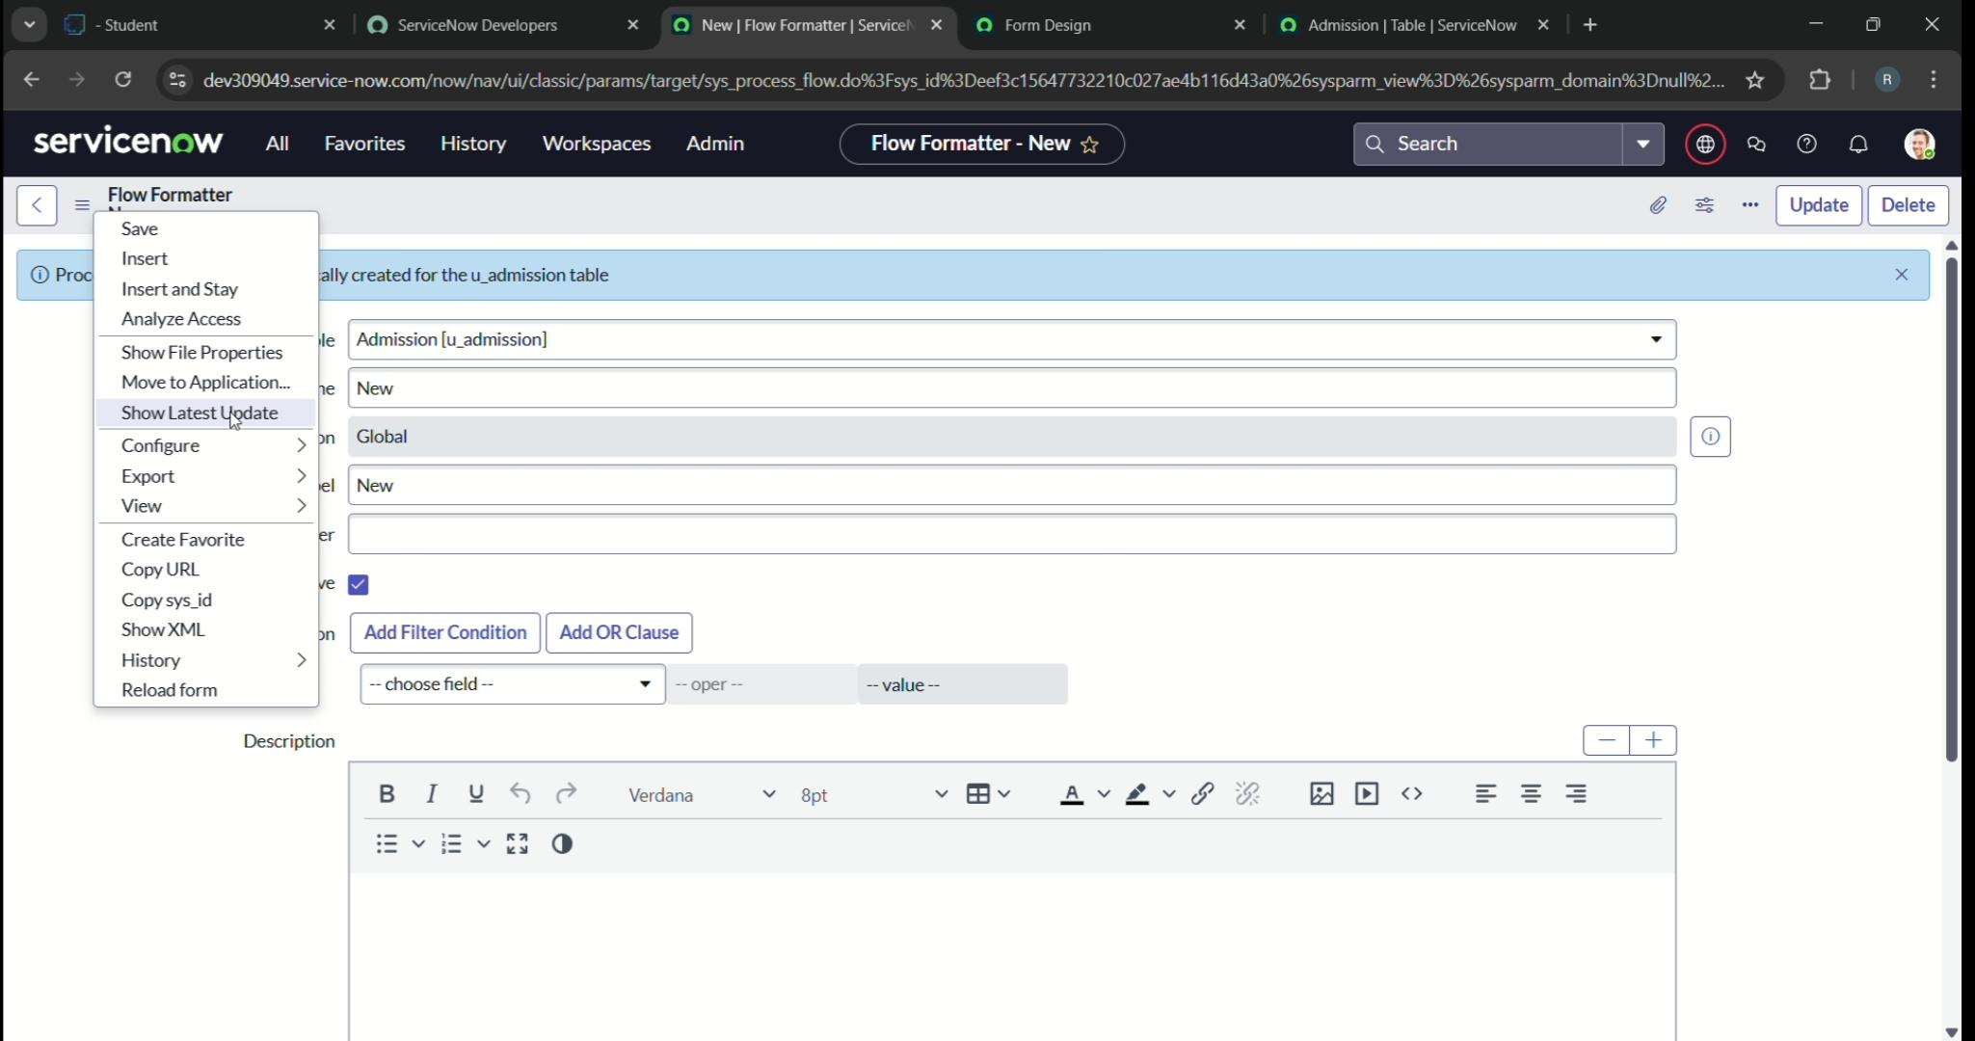

**Milestone 7: Client Script**

**Activity 1: Creating “Auto Populate” client Script for Admission table**

1. Open service now
2. All>> Client Script>>New
3. 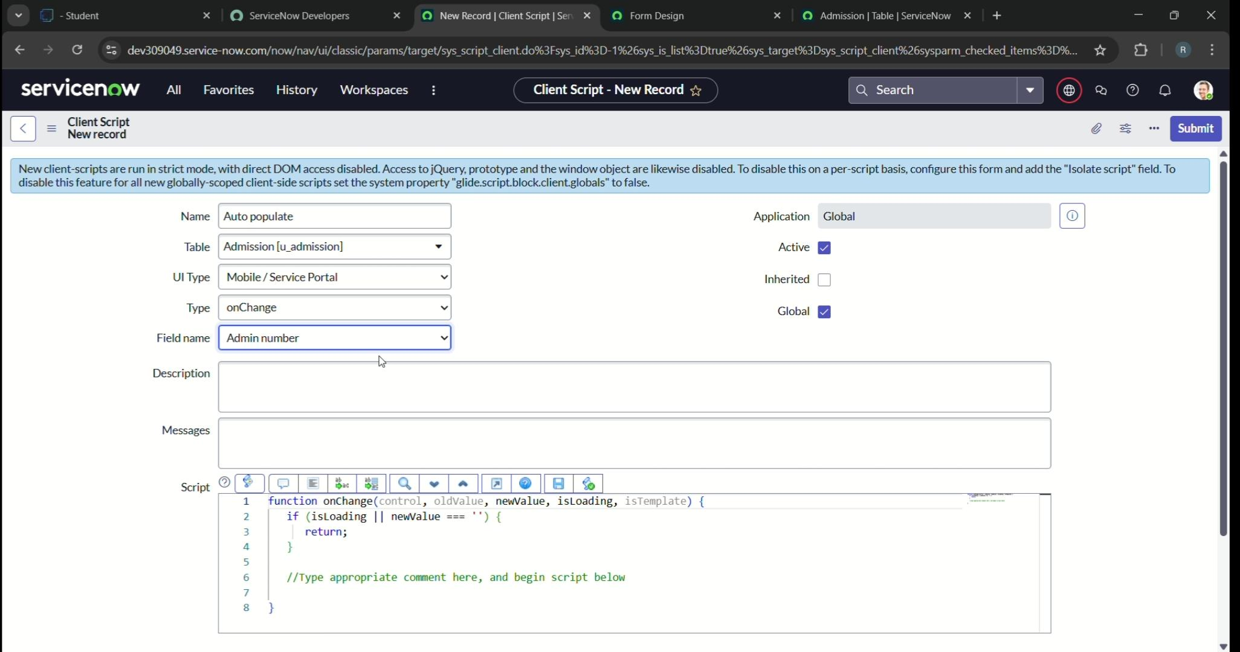Fill the details as given

4. Write the Code as below, Enable Isolate script and Save.

Function onChange(control, oldValue, newValue, isLoading, isTemplate) {

If (isLoading || newValue === ‘’) {

Return;

}

//Type appropriate comment here, and begin script below

Var a = g_form.getReference(‘u_admission_number’);

G_form.setValue(‘u_admin_date’,a.u_admin_date);

G_form.setValue(‘u_grade’,a.u_grade);

G_form.setValue(‘u_student_name’,a.u_student_name);

G_form.setValue(‘u_father_name’,a.u_father_name);

G_form.setValue(‘u_mother_name’,a.u_mother_name);

G_form.setValue(‘u_father_cell’,a.u_father_cell);

G_form.setValue(‘u_mother_cell’,a.u_mother_cell):

G_form.setDisabled(‘u_admin_date’,a.u_admin_date);

G_form.setDisabled(‘u_grade’,a.u_grade);

G_form.setDisabled(‘u_student_name’,a.u_student_name);

G_form.setDisabled(‘u_father_name’,a.u_father_name);

G_form.setDisabled(‘u_mother_name’,a.u_mother_name);

G_form.setDisabled(‘u_father_cell’,a.u_father_cell);

G_form.setDisabled(‘u_mother_cell’,a.u_mother_cell);

}

}

}

**Activity 2: creating pin code update silent trip for admission table**

1. Open service now
2. All>> Client Script>>New
3. 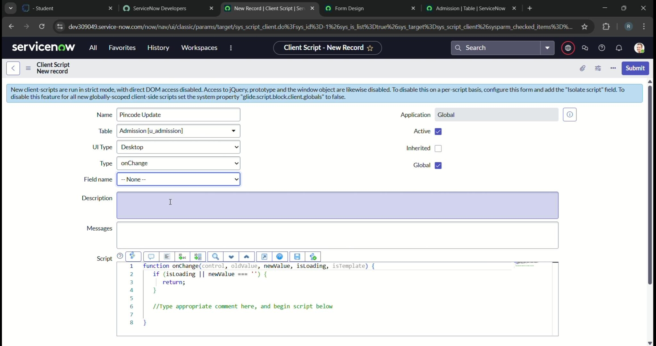Fill the details as given
4. Write the Code as below, Enable Isolate script and Save.

Function onChange(control, oldValue, newValue, isLoading, isTemplate) {

If (isLoading || newValue === ‘’) {

Return;

}

Var a = g_form.getValue(‘u_pincode’);

If(a == ‘509358’)

{

G_form.setValue(‘u_mandal’, ‘kadthal’);

G_form.setValue(‘u_city’, ‘kadthal’);

G_form.setValue(‘u_district’, ‘RangaReddy’);

Else if(a == ‘500081’)

{

G_form.setValue(‘u_mandal’, ‘karmanghat’);

G_form.setValue(‘u_city’, ‘karmanghat’);

G_form.setValue(‘u_district’, ‘RangaReddy’);

}

Else if(a == ‘500079’)

{

G_form.setValue(‘u_mandal’, ‘Abids’);

G_form.setValue(‘u_city’, ‘AsifNagar’);

G_form.setValue(‘u_district’, ‘Hyderabad’);

}

//Type appropriate comment here, and begin script

}

**Activity 3: Creating Disable Field Update client script for admission**

1. Open service now
2. All>> Client Script>>New
3. Fill the details as given

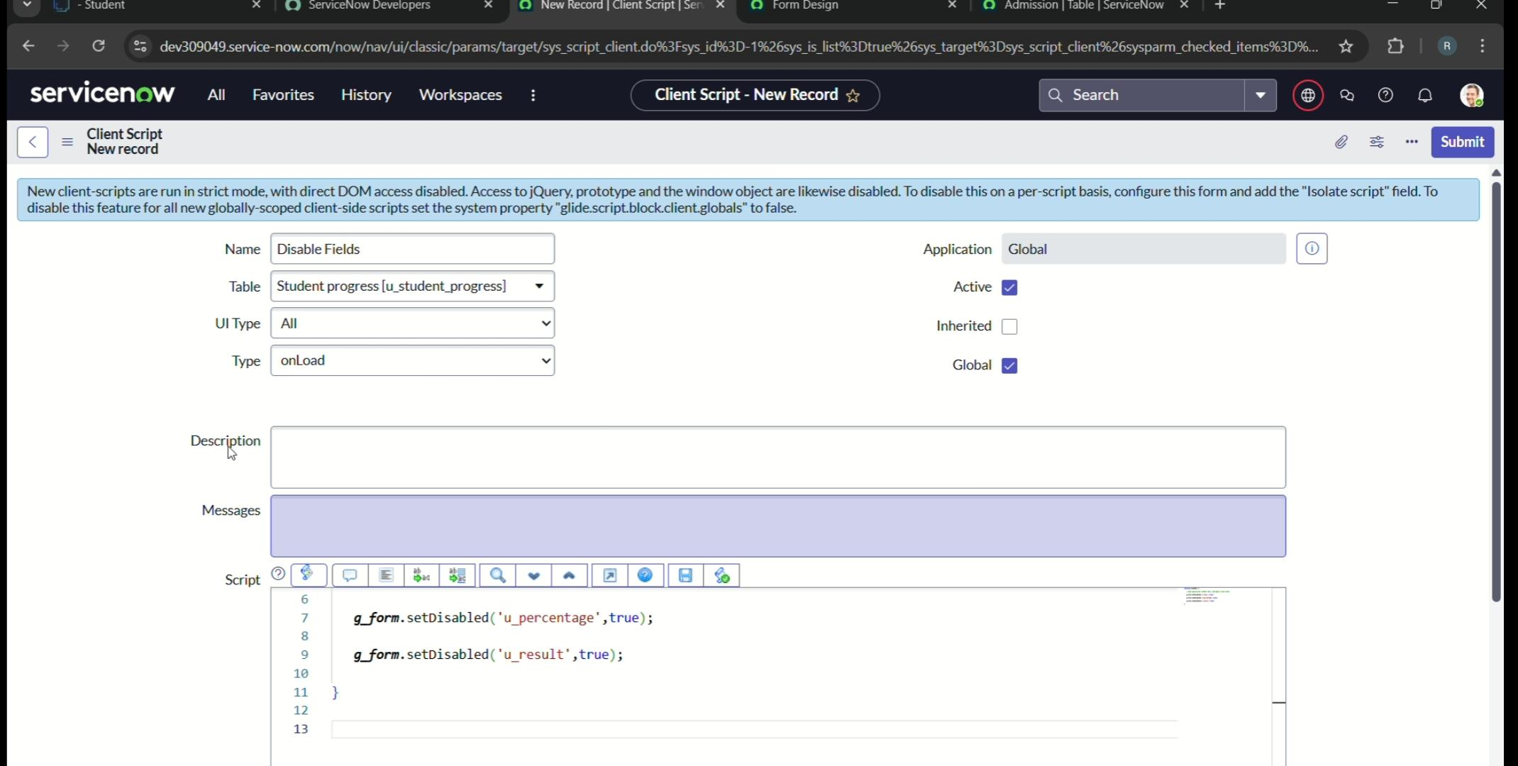

1. Write the Code as below, Enable Isolate script and Save.

Function onLoad()

//Type appropriate comment here, and begin script below

G_form.setDisabled(‘u_total’,true);

G_form.setDisabled(‘u_percentage’,true);

G_form.setDisabled(‘u_result’,true);

}

**Activity 4 : Creating Resul client script for Student progress**

1. Open service now
2. All>> Client Script>>New
3. Fill the details as give

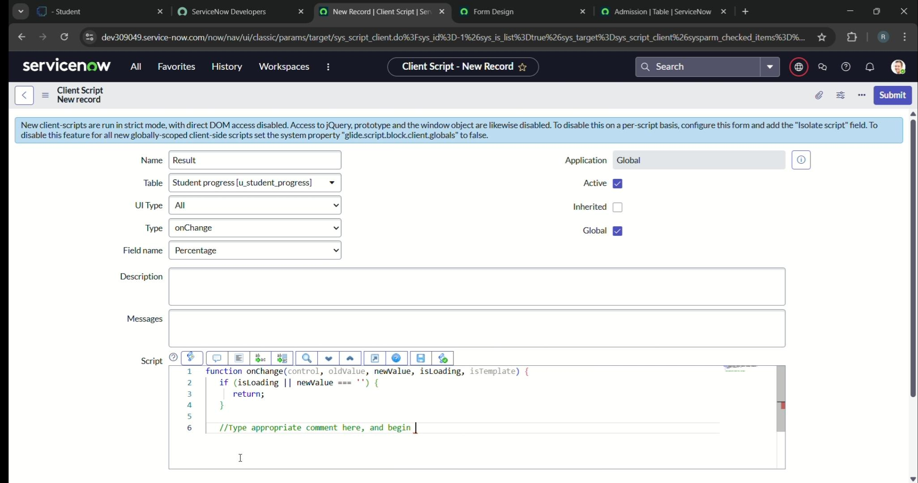

1. Write the Code as below, Enable Isolate script and Save.

Function on Change(control, oldValue, newValue, isLoading, isTemplate) {

If (isLoading || newValue === ‘’){

Return;

}

//Type appropriate comment here, and begin script below

If(newValue) {

Var a = parseInt(g_form.getValue(‘u_percentage’)); // Convert the value to an integer for comparison

If(a >= 0 && a <= 59{

G_form.setValue(‘u_result’,’Fail’);

} else if(a >= 60 && a <= 100) ;

G_form.setValue(‘u_result’,’Pass’);

} else{

// Handle the case if a is out of range (optional)

G_form.addErrorMessage(‘Percentage should be between 0 and 100.’);

G_form.clearValue(‘u_result’);

}

}

}

**Activity 5: Creating Total update client script for Student progress Table**

1. Open service now
2. All>> Client Script>>New
3. Fill the details as given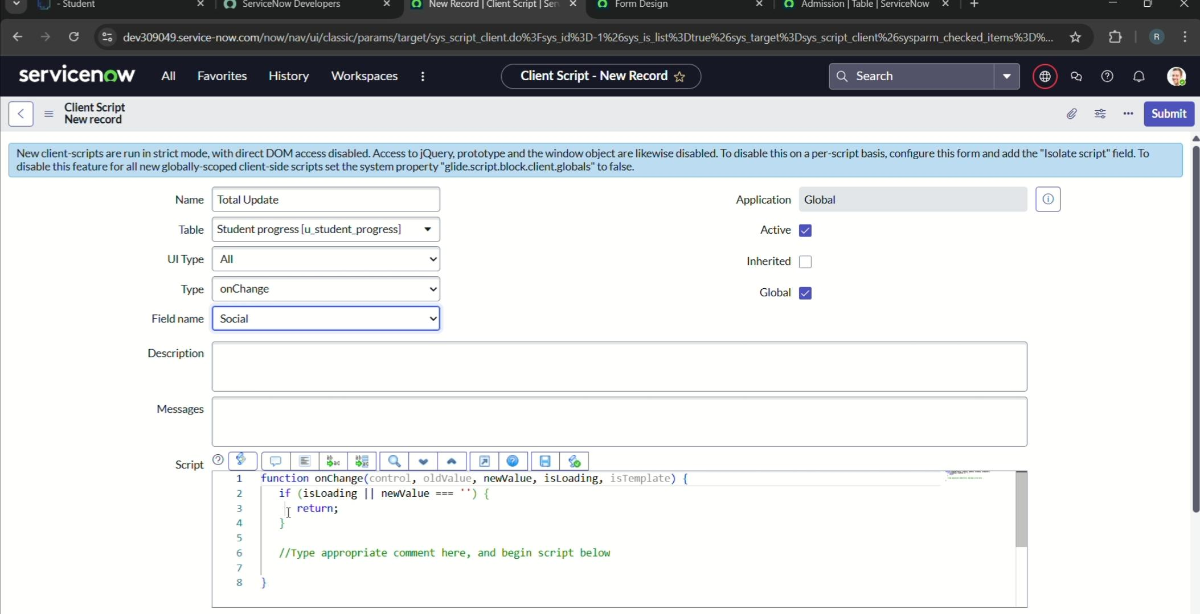
4. Write the Code as below, Enable Isolate script and Save.

Function onChange(control, oldValue, newValue, isLoading, isTemplate) {

If (isLoading || newValue === ‘

Return;

}

//Type appropriate comment here, and begin script below

If (newValue);

Var a = parseInt(g_form.getValue(‘u_telugu’));

Var b = parseInt(g_form.getValue(‘u_hindi’));

Var c = parseInt(g_form.getValue(‘u_english’));

Var d = parseInt(g_form.getValue(‘u_maths’));

Var e = parseInt(g_form.getValue(‘u_science’));

Var f = parseInt(g_form.getValue(‘u_social’));

Var Total = parseInt(a+b+c+d+e+f);

G_form.setValue(‘u_total’, Total);

}

}

}

**Activity 6: Creating Persnndaege client script for Student progress Table**

1. Open service now
2. All>> Client Script>>New
3. Fill the details as given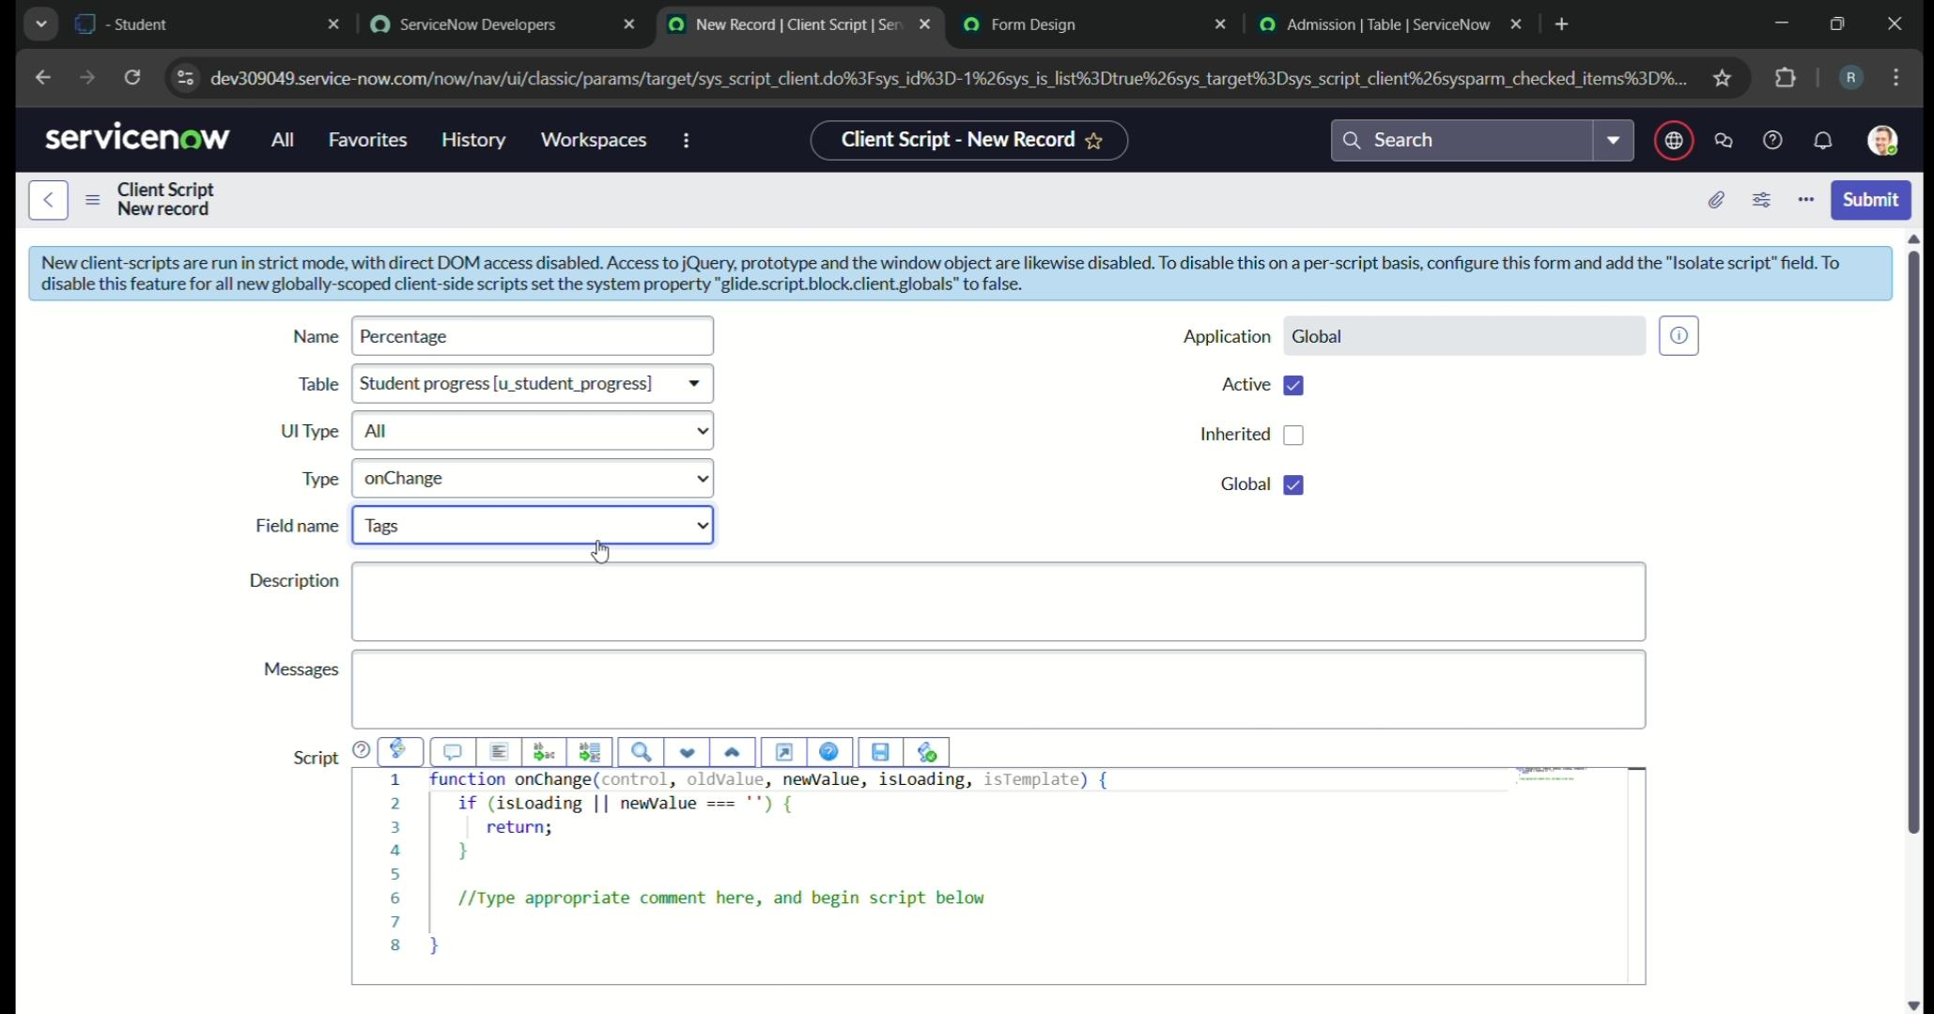
4. Write the Code as below, Enable Isolate script and Save

Function onChange(control, oldValue, newValue, isLoading, isTemplate) {

If (isLoading || newValue === ‘’) {

Return;

}

//Type appropriate comment here, and begin script below

Var Total = g_form.getValue(‘u_total’

Var Percentage = (Total/600)*100;

G_form.setValue(‘u_percentage’,Percentage+’%’);

}

**Milestone 8 : Result**

**Activity 1:Result**

